I am planning to code my application in C#. I am import SQL database dll’s in my code and connect to my database through a connection string. I will pass in the sql string in the data table and call that data table in my Asp.net grid view. When the user will update data through the grid view, the code in the backend will be passing the user text through sql parameters into the database. The code will also check user is not entering any duplicate data. If the data is not correct, the code will generate a popup message to the user which will inform them the exception and ask them to correct and reenter the data. If the user data is correct, the sql parameter will pass the data into the database. The code will keep the grid view updated with the current data in the database.

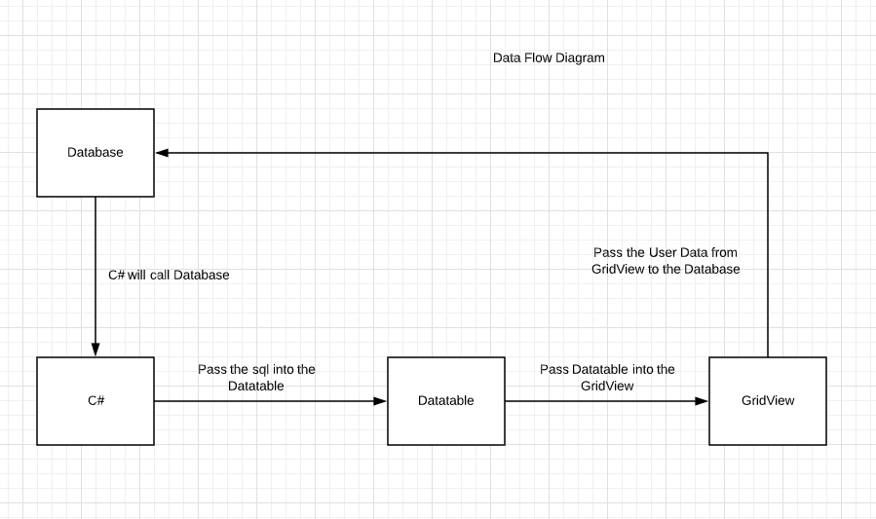

The webpage will generate error message in this format (This is just an example):



I will not be using any API to connect with the database. I will use direct database connection to call the database.

Stretch Feature (After MVP): The user login screen will call a different table that stores customer data. The grid View will call 2 tables in a sql join statement which will get updated when a user or customer make any update to the data in those tables.